Week 7
10. React-HOL
Define JSX
JSX (JavaScript XML) is a syntax extension for JavaScript that allows you to write HTML-like code inside JavaScript.
const element = <h1>Hello, world!</h1>;
JSX makes UI code easier to write and understand.

Explain about ECMAScript
ECMAScript (ES) is the standardized version of JavaScript.
ES6 (ECMAScript 2015) introduced modern features like:
- let, const
- Arrow functions
- Classes
- Modules
- Promises

Explain React.createElement()
React.createElement() is a core React method that creates and returns a React element (JS object).
JSX is converted into React.createElement() behind the scenes.
Example:
React.createElement('h1', null, 'Hello')
is equivalent to:
<h1>Hello</h1>

Create React Nodes with JSX
React nodes (elements) can be created using JSX like:
const element = <h2>Welcome!</h2>;
These nodes can be returned from functions or rendered in the DOM.

Render JSX to DOM
React uses ReactDOM.render() to mount JSX elements to the browser's DOM.
Example:
ReactDOM.render(<App />, document.getElementById('root'));

Use JavaScript Expressions in JSX
You can embed any valid JavaScript expression inside {} in JSX.
Example:
const name = "John";
const element = <h1>Hello, {name}</h1>;

Use Inline CSS in JSX
Inline styles are written as JavaScript objects in JSX, using camelCase property names.
Example:
const styleObj = { color: 'blue', fontSize: '20px' };
<h2 style={styleObj}>Styled Text</h2>
Or directly:
<h2 style={{ color: 'red' }}>Red Text</h2>
Code:-
App.js :-
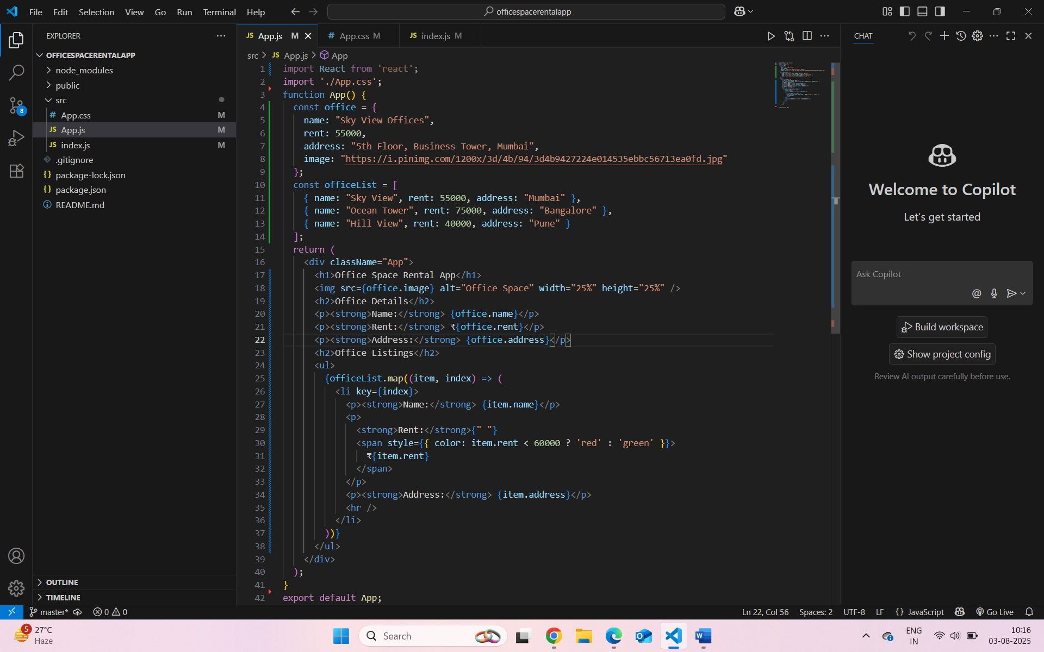

App.css :-
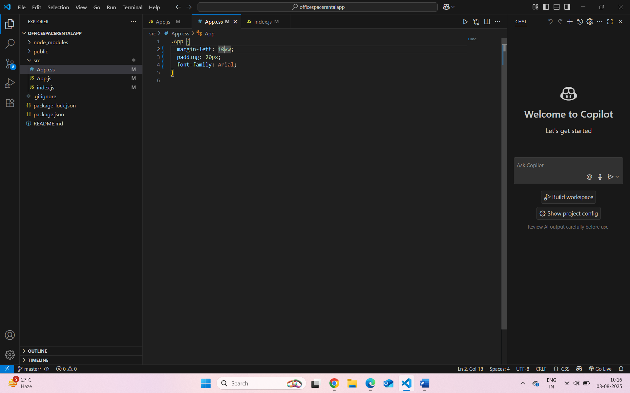
Localhost:3000 :-
